
Somerset Phoenix Project
Parent or Carer request for support form

Please use this form if you are a parent or carer requesting support for your child.
If you need help to complete this form, please contact us on 07590 627693.

Consent
Has the young person consented to this request for support (delete as appropriate)? | Yes or No
Does the child or young person consent to professionals in their lives being contacted? (Delete as appropriate) | Yes or No
Is this the first time they have been referred to the Somerset Phoenix Project? (Delete as appropriate) | Yes, No or Unknown

About your child or young person
First name: |  |  |  |  |  |  |  |  |  | Last name:
Age: |  |  |  |  |  |  |  |  |  | Date of birth:
Gender identity: |  |  |  |  |  |  |  |  |  | Sex assigned at birth:
Sexual orientation: |  |  |  |  |  |  |  |  |  | Religion/belief:
Ethnicity:
Disabilities/allergies/special educational needs:
(including physical, learning, sensory,
communication or other needs)
Child/young person’s address:
Must live in the Somerset Council area. Looked after children (LAC) placed out of county who usually reside in Somerset cannot at this time access our service
Child or Young Person’s Contact Details
If the young person is over the age of 13 we must have the best phone number to contact them on.
Please indicate whether the young person wants to be contacted through their parents, school/college or directly.
Who does the child or young person want us to contact first to make initial contact:
Phone numbers:
Email:
* Mark with a ‘x’ if Phoenix can…
Call |  | Email |  | Text |  |  | Leave a voicemail |  | Post to your address |  |  |  | WhatsApp

Education Setting Details
*Name of school:
*Key professional who is working alongside your child:
*Contact details (telephone and email address):

About you

*First name: |  |  |  |  |  | *Last name:
*Relationship to child:
*Address:
*Phone numbers:
Email address:
*Can we: | Call |  | Email |  | Text |  |  | Leave a message |  |  | Post to your address
Preferred way for us to contact you? Please state

Background
Is your child safe (i.e. no longer experiencing sexual abuse)? (Delete as appropriate) | Yes or No
When did the abuse stop?
When did your child tell someone about the abuse?
Is your child/young person involved with CAMHS (Child and Adolescent Mental Health Service)?
Please state past, current or if a referral to CAMHS has recently been submitted
What relationship did the person who harmed your child/young person have to them?
Is there a current court case or police investigation? | None, Current or Historic
Name and contact details of social worker if you have one:

Name of GP surgery (and name of GP if you know it):

*Family issues
We understand that life is tough, and your child and you might have gone through all sorts of issues; please put an X next to all that apply

Physical abuse |  | Sibling disability
Emotional abuse |  | Housing instability
Physical neglect |  | Experienced bullying
Emotional neglect |  | Low-income/financial struggles
Domestic abuse (including physical, emotional, financial, sexual, coercive) |  | Unemployment across the whole family
Parental/carer separation or divorce |  | Parental disability
Member of family in prison |  | Young carer
Parent/carer issues with drugs or alcohol |  | Special guardianship/adopted
Parental mental health |  | Parental self-injury
Bereavement in the family |  | Experienced female genital mutilation (any changes or cuts to a girl’s genitals)

*Trauma Symptoms
These are the behaviours that you have seen since the abuse happened; please indicate all known symptoms

Anger |  | School refusal
Sleeping issues |  | Excluded from school
Anxiety/panic attacks/worry |  | Poor school attendance
Low mood/depression |  | Guilt/shame
Eating issues |  | Bed-wetting
Self-injury |  | Overly compliant
Suicide ideation |  | Toileting excessively
Suicide attempt |  | Poor self-care/neglecting hygiene
Nightmares |  | Age regression
Flashbacks |  | Body image issues
Inappropriate relationships |  | Bodily or verbal tics
Risky behaviour including sexual |  | Abortion
Bullying others |  | Poor memory/concentration
Dissociation |  | Hoarding
Lying |  | Poor family relationship
Separation anxiety |  | Afraid to be anywhere near men/women
Friendship issues |  | Tries to maintain control
Watching porn |  | Excessive showering/bathing
Going missing |  | Spending substantial amounts of time in their room – more than you would expect
Stealing |  | Substance misuse by the child/YP
Attachment-seeking behaviour |  | CAMHS inpatient
Agoraphobia |  | Been bullied

Any further notes on presenting behaviours, emotional difficulties, or ACEs (Adverse Childhood Experiences):
(bullet points please, NO SEXUAL ABUSE DETAILS)
*Details of support or intervention already received: (bullet points please)

*Other agencies & professionals involved
with supporting your child or young person
E.g., Domestic Abuse Service/Drug & Alcohol Service/Mental Health Service
Name of Professional | Email and telephone details | Agency & Job Role

Returning the form & what happens next
Please email this form and any additional documents, e.g. Early Help Assessment (EHA), to:
somersetphoenixproject@barnardos.org.uk

Please note: We would prefer you to send this form back by encrypted email; we can help generate this for you. Alternatively, if you are happy to send it unencrypted, this is ok too.

Direct referrals to any of the team’s accounts will not be processed.

If you don’t hear from us within 5 working days of sending your form, please contact us to make sure we have received it.

What happens next?
You will receive an email to confirm receipt of the form and acknowledge that it meets criteria. The email will also contain a link to book a follow-up call. We understand that talking through your child’s struggles can be hard and we will go at your pace.

The person you will speak to is the manager of the service - it is their job to make this referral process as easy as possible and get you the right amount of support based on you and your family’s needs.

Once we’ve got your referral form and spoken to you, the manager will take it to the next triage meeting.

Triage meetings usually occur on the 1st and 3rd Tuesday of each month. Triage cases are sent to the triage team on the 2nd and 4th Tuesday of every month so that we have a week to read all the information and make an informed decision.

Please note: The Phoenix Team operates Monday to Friday (9:30am-4pm).

Somerset Phoenix Project is a partnership between:
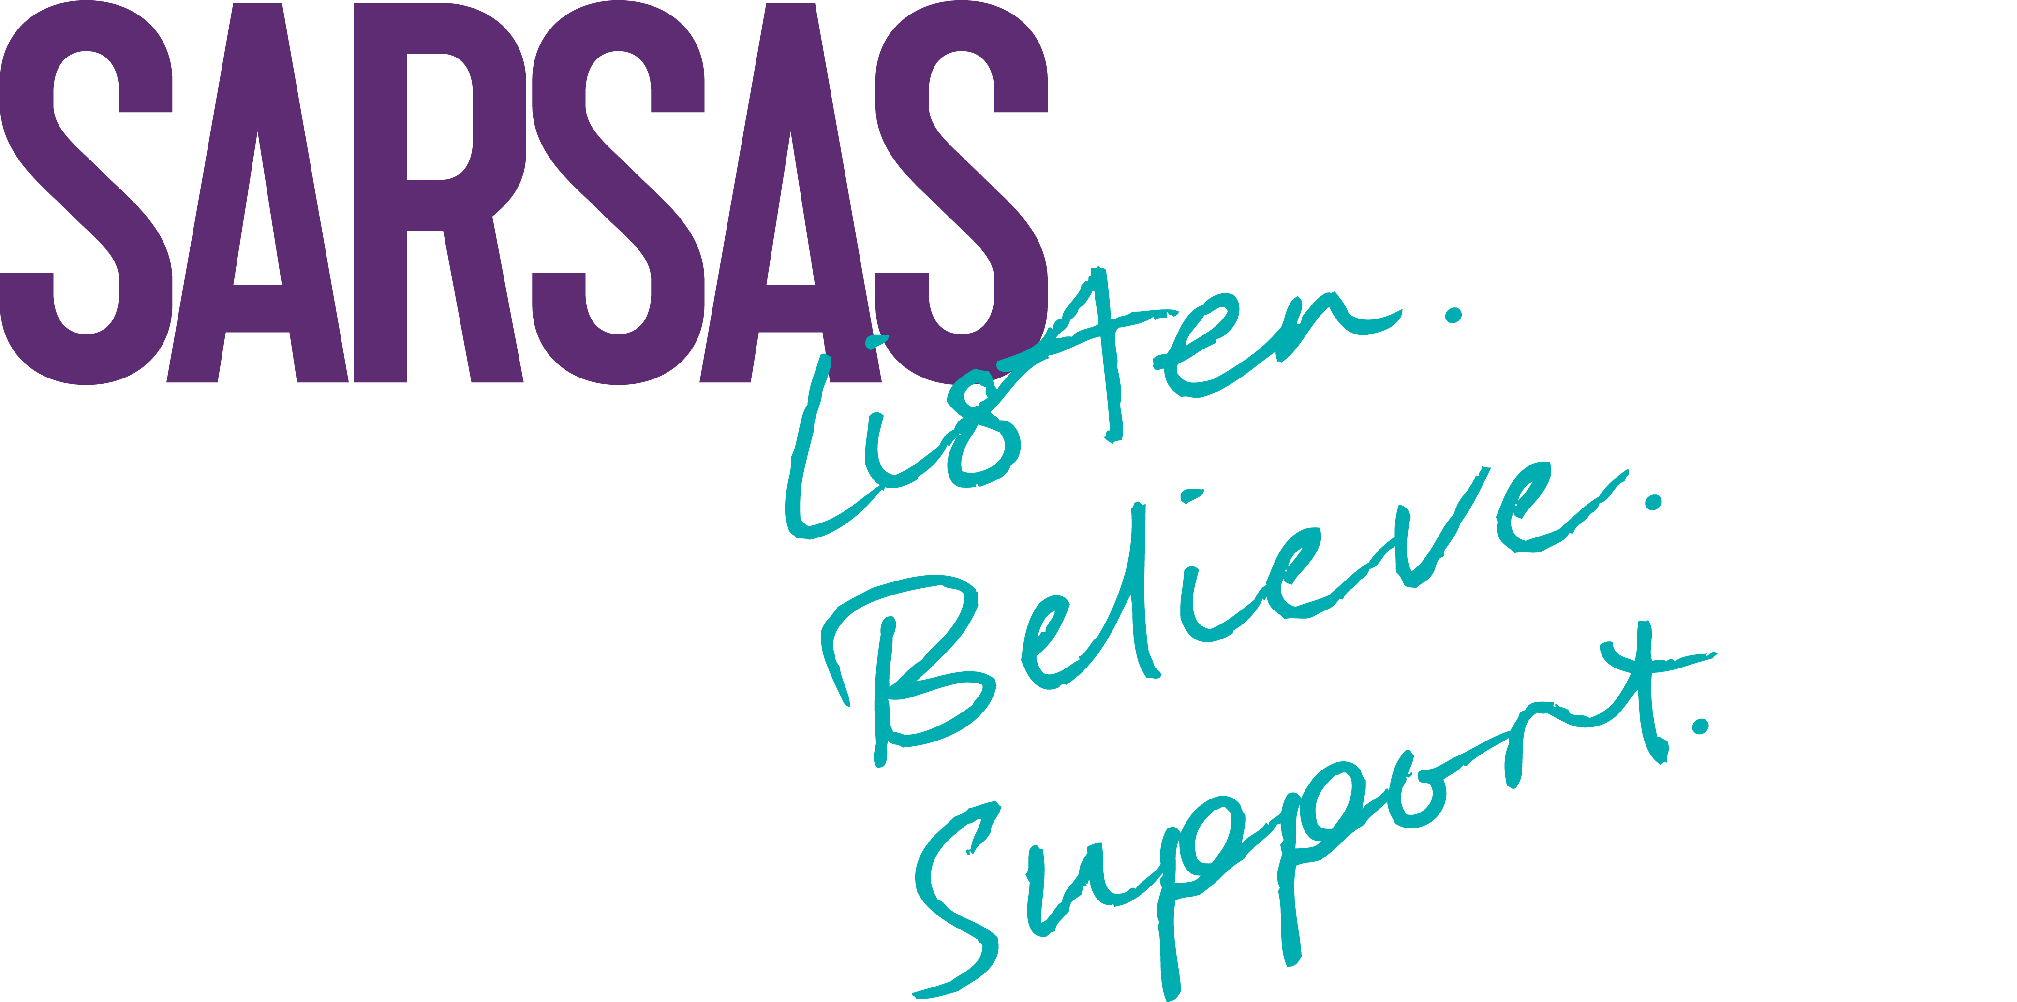



For office use only

 | Direct Specialist  Support |  |  |  | Indirect Specialist Support |  |  |  | Counselling
Number of ACEs
Previous referrals to SPP and no support offered
Number of other agencies involved
Therapeutic support already had
Number of trauma behaviours
GCSE year
Total

